  - 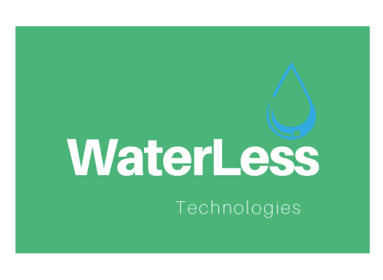
  - SOUTH PACIFIC WATERLESS LTD
Help Line: 0800 99 8000 Email:sales@waterless.co.nz

Order request form

CONTACT INFORMATION
Date: |  | Email:
Company Name: |  | Delivery Address:
Contact Name:
Phone number |  | Billing Address:
Order number

products required
Stock Code: |  | Quantity required:
Flax Urinal:

Kea Urinal:

WUVCCW
(cartridge for Flax urinals.)
WUD3CW
(cartridge for Kea/Fibreglass models.)

COMMENTS

